Aim:-Implement digital signature algorithms such as RSA-based signatures, and verify the
integrity and authenticity of digitally signed messages.
CODE:
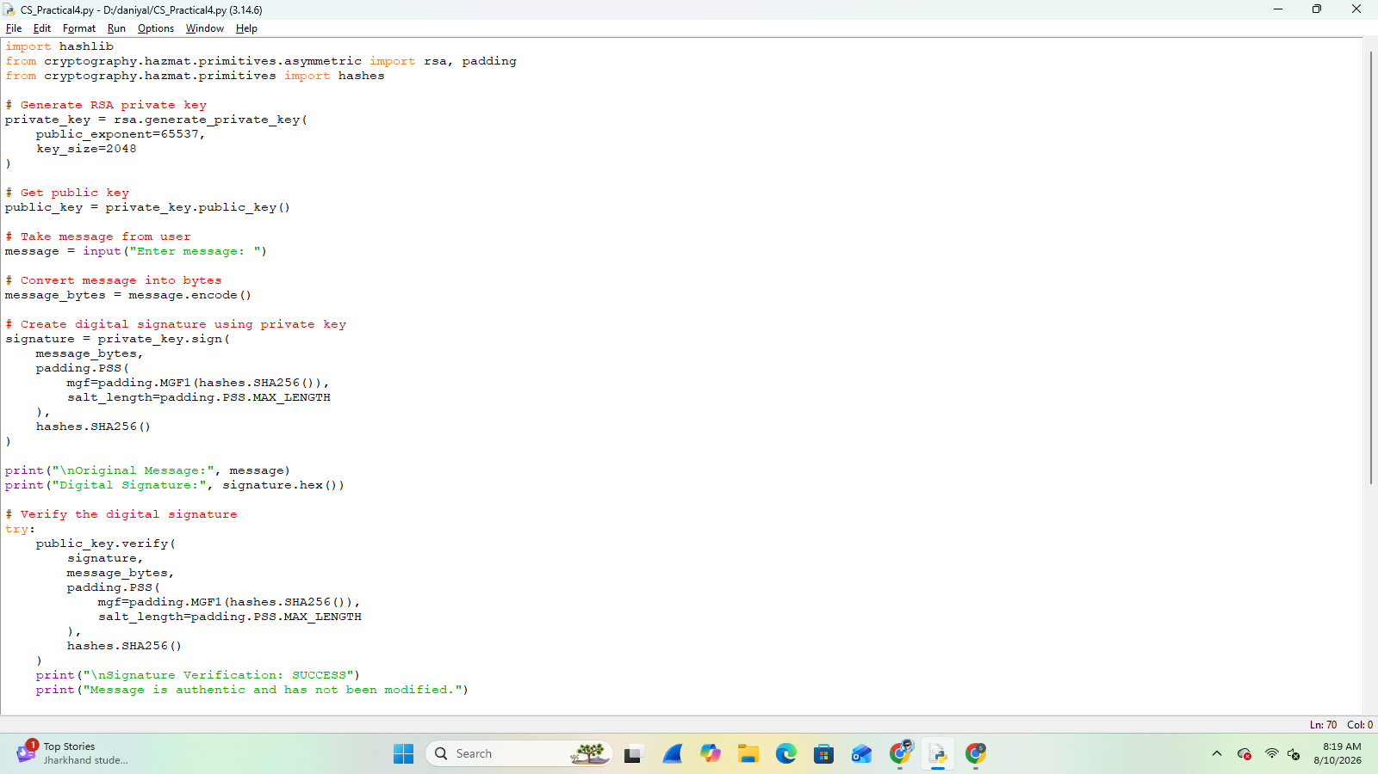

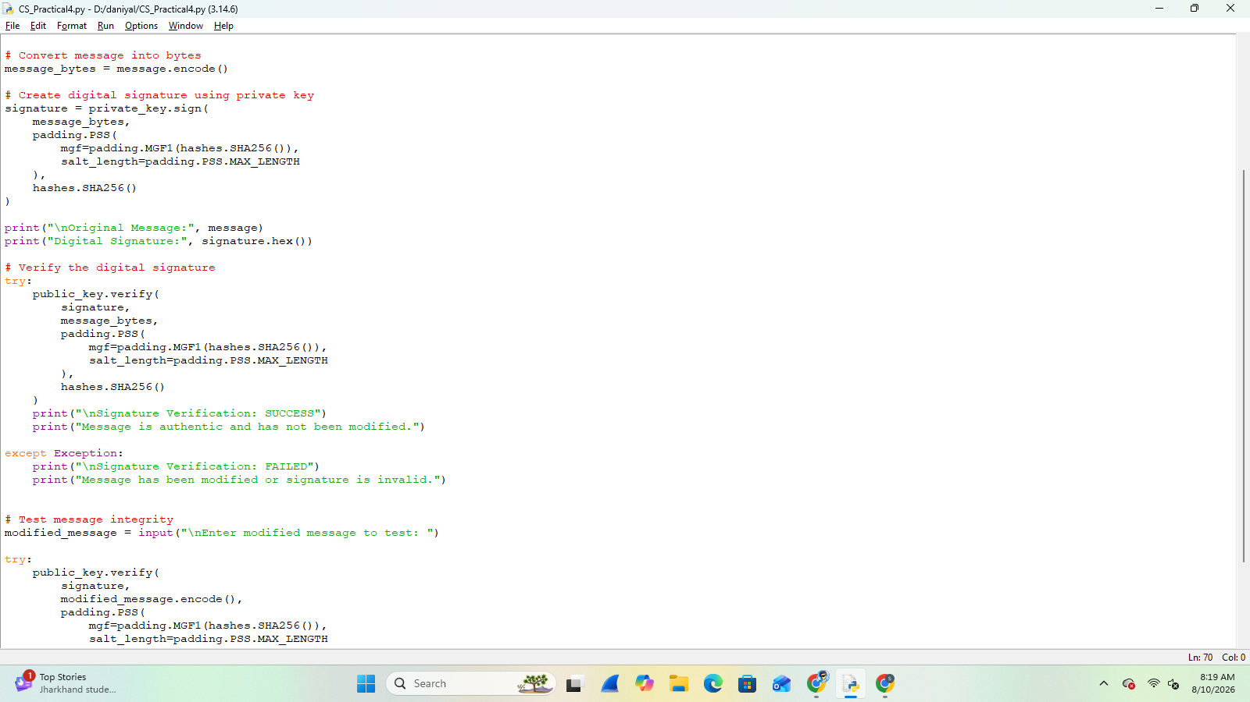

OUTPUT:-
